Community Council Report
Llandow Ward
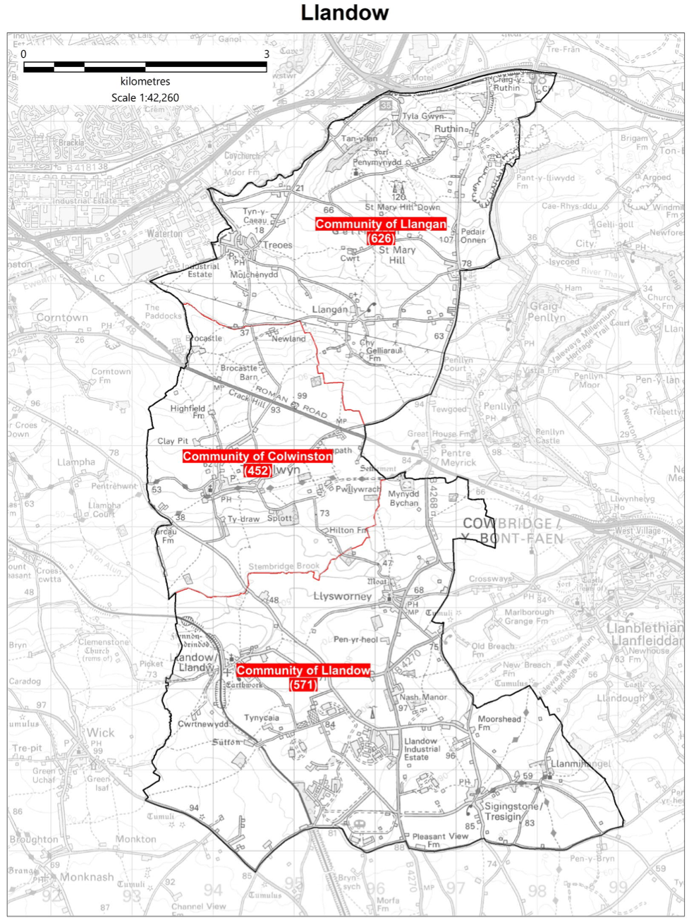
Cllr. Christine Cave email: cacave@valeofglamorgan.gov.uk
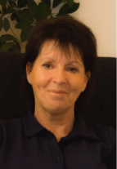
Date: April/May 2024 Report to the Community Councils (CC) in the Llandow Ward: Colwinston; Llandow, Llysworney, Sigingstone, Sutton and Llangan/Treoes and St Mary Hill.

Vale of Glamorgan Full Council meeting date to April 2025

8th May Annual meeting

15th July, 2024

30th September, 2024

2nd December, 2024

3rd March, 2025

28th April, 2025.

Full Council Meeting 29th April 2024

HYBRID MEETING

Agenda

PART 1

1. Apologies for absence.

2. (a) To hear the roll call of Members.
(b) To receive declarations of interest and the nature of such interests under the Council’s Code of Conduct.
(Note: Members seeking advice on this item are asked to contact the Monitoring Officer or Democratic Services at least 48 hours before the meeting.)

3. To approve the minutes of the meeting held on 6th March, 2024.

4. To receive any announcements from the Mayor, Leader, Members of the Cabinet and the Chief Executive and to receive any petitions submitted by Members.

5. Questions from the Public –
3 questions have been received.

Report of the Executive Leader and Cabinet Member for Performance and Resources –
6. Vale of Glamorgan Community Review.

Report of the Chief Executive –
7. Use of the Chief Executive’s Emergency Powers.

8. To consider the following proposal(s) from the Executive in relation to the Council’s Policy Framework and Budget

Item | Date of Meeting | Minute No.
(a) Proposal to Grant Freemen and Freewomen Status to the Royal National Lifeboat Institution (1) | 11th April, 2024 | C310

N.B. The report which is the subject of the reference in respect of Agenda Item 8(a) above has already been circulated to Members with the Cabinet agenda for 11th April, 2024.

****Further copies are available from the Democratic Services Office if required**.

9. Nomination of Mayor Elect and Deputy Mayor Elect for the Municipal Year 2024/25.

10. To inform the Council of the Use of the Urgent Decision Procedure under Article 15.14 of the Constitution.

Item | Date of Meeting | Minute No.
(a) Draft Budget 2024/25 and Medium Term Financial Plan 2024/25 to 2028/29 (8) | 29th February, 2024 | C260
(b) Capital Strategy 2024/25 and Final Capital Programme Proposals 2024/25 to 2028/29 (5) | 29th February, 2024 | C261
(c) Treasury Management and Investment Strategy 2024/25 and Update 2023/24 (6) | 29th February, 2024 | C262
(d) Strategic Equality Plan 2024-25 (2) | 21st March, 2024 | C292

11. To receive questions and answers pursuant to Section 4.19.2 – 4.19.9 of the Council’s Constitution (i.e. questions on any matter in relation to which the Council has powers or duties or which affects the Vale of Glamorgan).

12. Any items which the Mayor has decided are urgent (Part I).

PART II
THE PUBLIC AND PRESS MAY BE EXCLUDED FROM THE MEETING DURING CONSIDERATION OF THE FOLLOWING ITEM(S) IN ACCORDANCE WITH SECTION 100A(4) OF THE LOCAL GOVERNMENT ACT 1972.

13. Any items which the Mayor has decided are urgent (Part II).

Cabinet meetings – April 2024

Members of the Cabinet
Councillor L. Burnett (Executive Leader and Cabinet Member for Performance and Resources) – Labour Party
Councillor B.E. Brooks (Deputy Leader and Cabinet Member for Sustainable Places) – Labour Party
Councillor R.M. Birch (Cabinet Member for Education, Arts and the Welsh Language) – Labour Party
Councillor M.R. Wilson (Cabinet Member for Neighbourhood and Building Services) Labour Party
Councillor M.R. Wilkinson (Cabinet Member for Public Sector Housing and Tenant Engagement) Labour Party
Councillor E. Williams (Cabinet Member for Social Care and Health) Llantwit First Party
Councillor S. Sivagnanam (Cabinet Member for Community Engagement, Equalities and Regulatory Services) Labour Party
Councillor G. John (Cabinet Member for Leisure, Sport and Well-being) Llantwit First Party

11th April 2024
https://www.valeofglamorgan.gov.uk/Documents/_Committee%20Reports/Cabinet/2024/24-04-11/Minutes.pdf

25th April 2024
https://www.valeofglamorgan.gov.uk/Documents/_Committee%20Reports/Cabinet/2024/24-04-25/Minutes.pdf

Consultations - Vale of Glamorgan Council

Current consultations are available at: https://participate.valeofglamorgan.gov.uk

Current consultation “Placemaking”

https://participate.valeofglamorgan.gov.uk/placemaking-cowbridge

The Local Democracy and Boundary Commission has published its Final Recommendations for the future community arrangements for the County Borough of The Vale of Glamorgan and submitted them to Welsh Government Ministers on 16 April 2024. It is now for Welsh Government and its Ministers to decide how to proceed. Ordinarily they will make an Order.

The Final Recommendations Report contains all of the Commission’s recommendations for the County Borough of The Vale of Glamorgan. Where it has made changes to the existing arrangements a description of the change, the representations it has received, the reasons for any change and a map of the recommendations are contained in the report.

The reports, maps and other supporting information for the review can be found below.

If you have any views on the Final Recommendations, these should be addressed to Welsh Government at the details below:

Local Government Democracy Team
Local Government Policy Division
Welsh Government
Cathays Park
Cardiff
CF10 3NQ

Or by email to:

LGPolicy.Correspondence@gov.wales

Further information about the review and the work of the Commission can be found on the Commission’s website.

Local Matters

Colwinston/Llangan/Llandow – Boundary Commission review of Town and Community Councils– letter of objection agreed – letter of objection sent 6th May 2024. Anyone wishing to object can do please see above review
- Colwinston – Adoption of the vines raised again with Director of Environment & Housing Services, Vale of Glamorgan Council – matter raised again with Miles Punter
- Colwinston – Street lights out on large section of A48 between the turnoff for Corntown to Llangan turnoff and by the cross roads entrance to Llysworney – repaired
- Colwinston – Village Hall roof repairs and possible transfer of assets – meeting with officer responsible - ongoing
- Colwinston – Litter bins not being emptied frequently – reported and ongoing
- Colwinston – damage to directional signs reported – ongoing
- Colwinston – Section 106 money – ongoing
- Colwinston – Green food waste bags replenished
- Colwinston/Llandow/Llangan – potholes and the poor state of the road surface reported again
- Llandow relocation of the current waste recycling center – awaiting further update
- Llandow – New 20 mph causing drainage issue – raised with highways - ongoing
- Llandow – Field run off meeting held at the end of January with a further meeting of the Llandow Action Group to be held in March 2024
- Llangan/Llandow - Leaflet developed with CC members to raise awareness of how to report traffic issues – provided clerk to Llangan CC with a named officer to support work with Gosafe Cymru
- Llangan/Colwinston/Llandow issues raised with Rob Thomas regarding the re-banding of homes in the ward – ongoing
- Llandow – Stolen directional signage reported to VoG – further damage to signage reported in April – ongoing
- Llandow – planning matter raised re holiday lets – ongoing
- Llangan – private planning matter raised – ongoing
- Llangan – confusion over signage outside of Llangan school reported to highways team – repaired
- Llangan – Greenlinks service – costs involved taken up with the VoG Managing Director Rob Thomas - ongoing

Scheduled Meetings for May 2024 - All Meetings commence at 6.00 p.m. and will be held virtually unless otherwise stated.

Council |  | Early Retirement/Redundancy
Annual Meeting  [View Live Stream - 8 May] | 8 May | Licensing - Public Protection (10.00 a.m.) | 14 May
Cabinet (2.00 p.m.) | 9 May;  23 May | Licensing - Statutory
Scrutiny (Corporate Performance and Resources) | 22 May | Licensing Sub (10.00 a.m.)
Scrutiny (Environment and Regeneration) | 21 May | Planning (4.00 p.m.) | 16 May
Scrutiny (Healthy Living and Social Care)  [View Live Stream - 14 May] | 14 May | Public Rights of Way
Scrutiny (Homes and Safe Communities)  [View Live Stream - 15 May] | 15 May | Senior Management Appointment
Scrutiny (Learning and Culture) | 13 May | Standards (10.00 a.m.) | 16 May
Appeals |  | Trust
Governance and Audit | 20 May  (Extraordinary) | Vale of Glamorgan Local Access Forum
Community Liaison |  | Voluntary Sector Joint Liaison
Democratic Services  (4.00 p.m.) |  | Welsh Church Act Estate  (4.00 p.m.)
Investigating |  | Shared Regulatory Services Joint Committee

